Erosion and Weathering Assessment Name ___________________

4th Grade

**Part A: Use your model to predict outcomes**

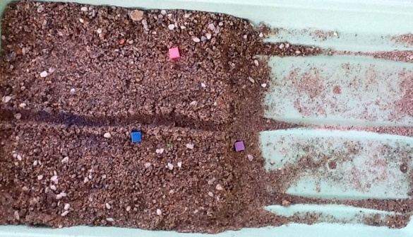

There are 3 ‘houses’ in the land depicted above. The channel in the middle becomes a river after rain. Use your understanding developed during this unit to make a claim about each of those houses. Provide your evidence, based on the investigations you did and recorded in your notebook, and your reasoning about that evidence.

|  |  |  |  |
| --- | --- | --- | --- |
| House | Claim | Evidence | Your Reasoning |
| A (blue) |  |  |  |
| B (pink) |  |  |  |
| C (purple) |  |  |  |

**Part B: Applying your understanding to similar phenomena**

Observe the Joshua Tree Rock Feature or the American River Canyon. Using diagrams and words, explain how you think ONE of these structures was formed.

In your writing, make a claim, and then back it up with evidence from your investigations, our class discussions, your group models and your claims/evidence writing. Include in your discussion references to WHAT happens, WHY it happens and an idea of how much TIME might be involved.

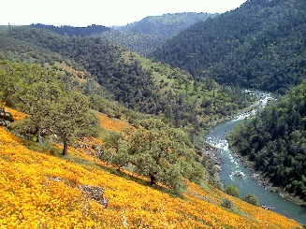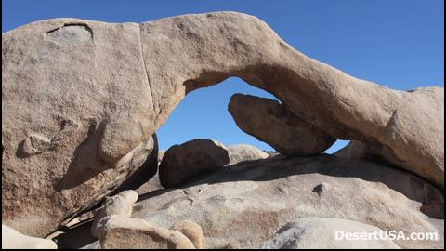

Joshua Tree American River Canyon

**Part C: Applying your Model to a New Phenomenon**

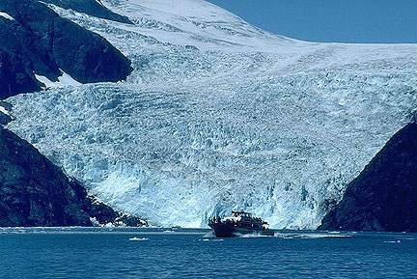A glacier is a layer of ice that doesn’t melt from year to year, but does move, as individual particles at the bottom layer slowly slide. Use your model to explain ***what you think will happen to the rock beneath this glacier*** as it slowly moves towards this sea. Use diagrams and words in your response, and be sure to make your thinking visible as best you can. Cite any evidence that will support your argument, and provide your reasoning as well.